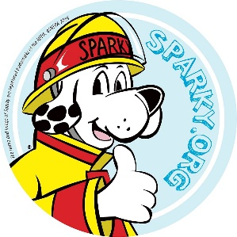

**January Kid Safe Fire-Safety Lesson from Collierville Fire and Rescue**

Welcome back! We’ve got a fun activity to accompany your January fire-safety lesson!

This month, we’re going to learn to “stop, drop, cover, and roll” if our clothes catch on fire. This is an important skill to know even if kids will hopefully never have to use it.

**LESSON**

Have your students **watch** the videos below to learn how and when to stop, drop, cover, and roll.

1. Demo:

<https://www.youtube.com/watch?v=K3N-07f9VsA>

1. Song for fun:

<https://www.youtube.com/watch?v=SFQTOeENllE>

1. After viewing, kids should take turn **practicing** this skill.

**ACTIVITY**

Your class should have received a paper fire truck with our fire-safety lessons we’ve been learning on top. Put your own paper fire truck together and review the fire-safety messages on top.

We also have several coloring sheets available on the webpage under January.

|  |  |
| --- | --- |
|  | Kelsey Johnson  Public Education Specialist  Collierville Fire and Rescue  kjohnson@colliervilletn.gov  901-457-2485 (office)  901-601-0638 (cell) |